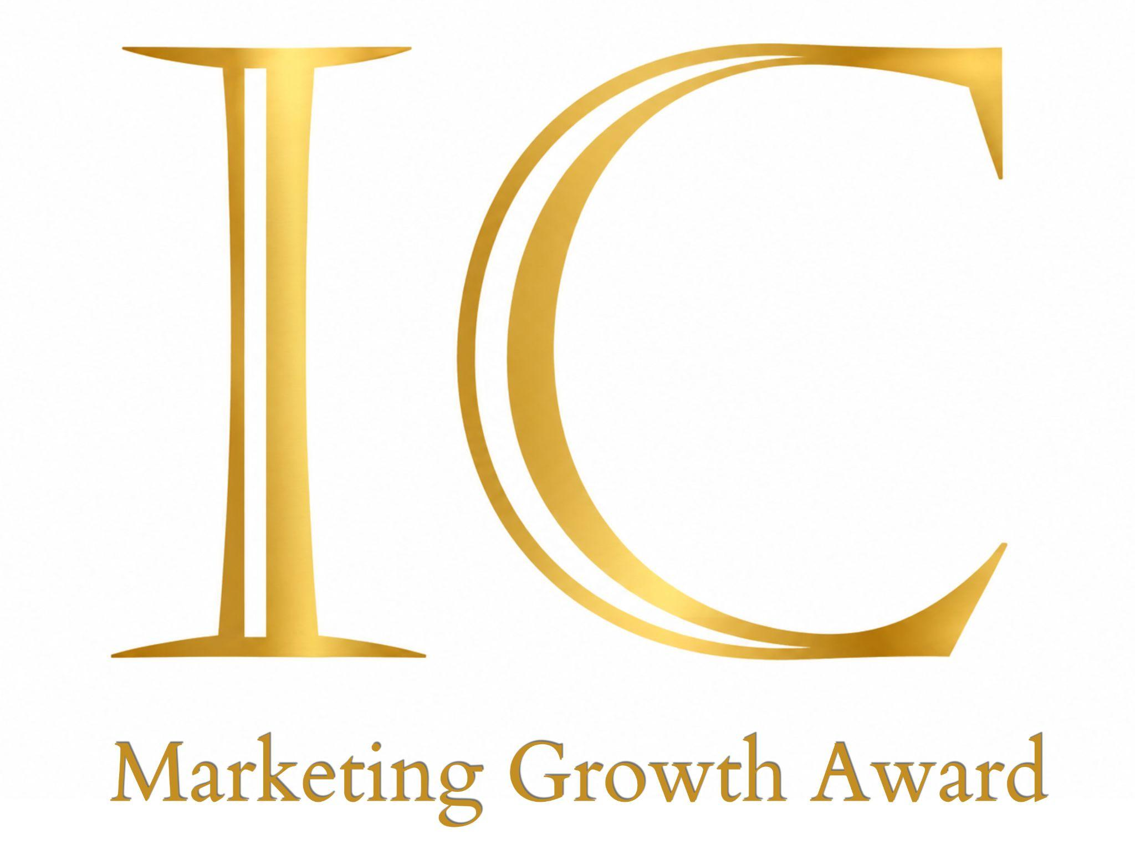

Application Form - please complete and email to isla@simply-ic.co.uk before
1 February 2027 at 5.00pm
Section 1 – About Your Organisation
Organisation name:
Registered charity number (where applicable):
Website:
Primary contact:
Position:
Email:
Telephone:
Organisation address:
Type of organisation:

Section 2 – About Your Organisation
Maximum 500 words
Please tell us about your organisation and its musical activity.
Please include:
- Your organisation's purpose or mission.
- The musical activities you provide.
- The people and communities you currently reach.
- Approximately how many people engage with your organisation each year.
- Your experience of successfully delivering musical projects, performances or participation activity.
We welcome applications from organisations for which music is one part of a wider charitable or community purpose.

Section 3 – Your Music Growth Project
Maximum 1000 words
Please describe the activity you would like the Simply IC Marketing Growth Award to support.
Please tell us:
- What you want to achieve.
- What musical activity you are seeking to grow.
- Who currently participates or engages.
- Who you would like to reach.
- What is currently preventing you from reaching those people.
- How you propose to address that challenge.
- How the Award funding would be used.
- Why your organisation is well placed to deliver the project.
- What difference the project could make to your organisation and community.
Please include an estimated project timeline.
All Award-funded activity must take place between July 2027 and July 2028.

Section 4 – Marketing and Audience Development
Maximum 500 words
Please explain how you intend to reach new participants or audiences.
You may wish to include:
- The audience or community you are trying to reach.
- What you know about that audience.
- The marketing channels you intend to use.
- Community, school or other partnerships.
- Digital advertising.
- Social media.
- Email.
- Print.
- PR or local media.
- Direct outreach.
- How your proposed approach differs from your existing marketing activity.
We are particularly interested in how you will reach people who do not currently engage with your organisation, rather than simply communicating with existing audiences.

Section 5 – Project Delivery
Who will be responsible for managing the project?
Name:
Role:
How will the project be delivered?
☐ Existing staff
☐ Volunteers
☐ Freelance professional(s)
☐ External agency or consultant
☐ Other – please specify
Why are you confident you can successfully deliver this project?
Maximum 200 words
Please outline the experience, resources, partnerships or expertise that will help ensure the project's success.
If you intend to use external professional support, please explain what expertise you expect to commission.

Section 6 – Expected Impact
Maximum 300 words
Please tell us:
- Approximately how many people will benefit.
- How many new participants or audience members you expect to reach.
- What opportunities the project will create.
- How you will know whether your marketing activity has worked.
- What information or data you will collect.
- What you hope will continue after the Award-funded period.
- Why the project could not achieve the same impact without the Award.
We encourage applicants to provide realistic and measurable targets.

Section 7 – Budget
Please provide a simple breakdown of how the Award funding would be spent.
Amount requested from the Simply IC Music Growth Award: £
Total project cost: £
Other funding secured: £
Other funding applied for: £
Please list the principal items you would use the Award to fund.
Where the Award forms part of a larger project, please make clear which elements the Simply IC Marketing Growth Award would specifically support.

Section 8 – Celebrating Success
The Simply IC Marketing Growth Award exists not only to fund activity but to celebrate organisations successfully growing musical participation.
Successful recipients will be expected to work with Simply IC to share the impact of their project.
Recipients agree to:
- Announce receipt of the Simply IC Marketing Growth Award through their website, newsletter and/or social media.
- Acknowledge the Award in relevant publicity and programmes.
- Use the Simply IC Marketing Growth Award logo where appropriate.
- Share reasonable progress updates during the funded period.
- Submit a short impact report within three months of completing the project.
- Share relevant results and audience data.
- Provide photographs and testimonials where appropriate permissions have been obtained.
- Grant Simply IC permission to feature the project and its outcomes across its website, publications, social media and future Marketing Growth Award communications.
- Where possible, invite a representative of Simply IC to attend an Award-supported event or activity.
By sharing these stories, recipients will help demonstrate how effective marketing can widen access to music, grow participation and strengthen communities across Greater London.

Assessment Criteria
Applications will be assessed equally against four criteria.
Participation
Will the project help more people engage with music?
Judges will consider the number of new people the organisation expects to reach and whether the proposed activity has the potential to widen participation.
Community Impact
Will reaching these people make a meaningful difference?
Judges will consider who will benefit, whether the project addresses a genuine barrier to participation and how it could strengthen connections within the community.
Deliverability
Is there a credible plan for reaching the intended audience?
Judges will consider the organisation's capacity, marketing approach, leadership, budget and ability to successfully deliver and measure the proposed activity.
Legacy
Will the benefits continue beyond the Award period?
Judges will consider whether the project could create lasting audience relationships, improved marketing capability, stronger partnerships, useful audience knowledge or sustainable opportunities for future participation.

Section 9 – Declaration
I confirm that:
- The information provided in this application is accurate.
- My organisation meets the eligibility requirements of the Simply IC Marketing Growth Award.
- My organisation is not an existing client of Simply IC.
- Any Award funding received will only be used for the purposes described within this application.
- The funded activity will take place between July 2027 and July 2028.
- If successful, my organisation will comply with the requirements set out under Section 8 - Celebrating Success.
Name:
Position:
Signature:
Date:

Key Dates
1 December 2026
Applications open.
1 February 2027 at 5.00pm
Applications close.
February 2027
Applications are reviewed by the Simply IC Marketing Growth Award judging panel and successful organisations are notified.
March 2027
Awards are announced and funding released.
July 2027 – July 2028
Award-funded activity takes place.
During the project
Recipients share progress and outcomes with Simply IC.
Within three months of completion
Recipients submit a short impact report including results, audience data, photographs and reflections.

Privacy
Information provided in this application will be used for the administration and assessment of the Simply IC Marketing Growth Award and processed in accordance with UK data protection legislation.
Application information may be shared with members of the judging panel for the sole purpose of assessing applications and administering the Award.

About Simply IC
Simply IC is an audience-first marketing agency working with charities, churches and organisations across the music and arts sectors. We help organisations grow their impact through clear communication, creative thinking, audience development and meaningful engagement. We believe that marketing is about much more than promotion.
Good marketing helps organisations understand the people they want to reach. It helps remove barriers, build relationships, communicate value and create opportunities for people to become involved.
For musical organisations and programmes, that can mean a new singer joining a choir, a family attending its first concert, a young person discovering an orchestra, a church connecting its musical life with its surrounding community, or an ensemble developing an entirely new audience. When more people participate in music, communities become stronger.
The Simply IC Marketing Growth Award reflects our commitment to helping excellent musical activity reach the people and communities who could benefit from it.
For more information, please visit:
www.simply-ic.co.uk
If you would like to discuss an application, please contact:
Isla Cameron ACIM
Founder & Director, Simply IC
Audience-first Marketing for Arts & Business
isla@simply-ic.co.uk
07741 472224

